LDM Project Proposal ASP.NET

Team members:

Larisa Sabalin - Back-end, front-end, team lead :)

Dmitrii Kudrik - Responsible for back-end programming

Matthew Stinis - Responsible for front-end programming

Description of the project and scope:   
For our project, we would like to create an application using MVC architecture built around automobile services such as car repair and maintenance which would facilitate connecting customers in need to the most reputable garage closest to them.

We will log each transaction between customer and garage using a code-first database design.

Each customer record will hold a unique ID, name, phone number, and address. The transactions they've made with the garage they choose will be recorded in the transaction table.

For every garage, each record will hold a unique ID, the business’ name, address, phone number, and available services.

Each service offered will be on record by service ID, title, and short description. Finally, the transactions customers made with the garage they've chosen will be logged on record through a unique ID, a list of services with ID, customer ID and garage ID.

We will build a UI which displays a list of offered services and their cost for each garage. Customers (users) will be able to select services, open transactions and leave their info for communication.   
Users will be able to search for services using a text box which will open a page displaying a list of garages which offer the services being searched for.   
If all goes well and we have time, we would like to implement a Google Maps API to show users where the garages are located. We would also like to add a review section for each garage so that customers may share their experience with others.

Search view, Map view, Order Service/Transaction is to be designed on the go. Most probably as ViewModels. Some search functions will be on the general page of Garages and Services. Users will have authorization credentials based on their roles. Customer view will have Customer’s public reviews as a detailed view with a specification of their original location.

Models:

|  |  |
| --- | --- |
| Customer | ID  Name  Address PhoneNo  UserNameID |
| Garage | ID  Name  Address  PhoneNo  List<ServiceID> |
| Service | ID  Title  Description |
| Transaction | ID  List<ServiceID>  CustomerID  GarageID |

Views:

|  |  |
| --- | --- |
| Folders: | Views(Actions): |
| Customers | * Index: to display the list of all customers in a table format * Details: to display the rewievs that the users posted |
| Garages | * Index: to display the list of all garages in a table format * Details: to display the details of a garage (by clicking on a service the user will go to Services->Details) |
| Services | * Index: to display the list of all services in a table format(by clicking on a service the user will get the list of garages providing such service) Search will be available on services * Details: to display the details of a service. |
| API | * Index: to display the garages on the map using Google API |
| Transaction | * Index: to display a form to order a service * Details: to display the list of user transactions |

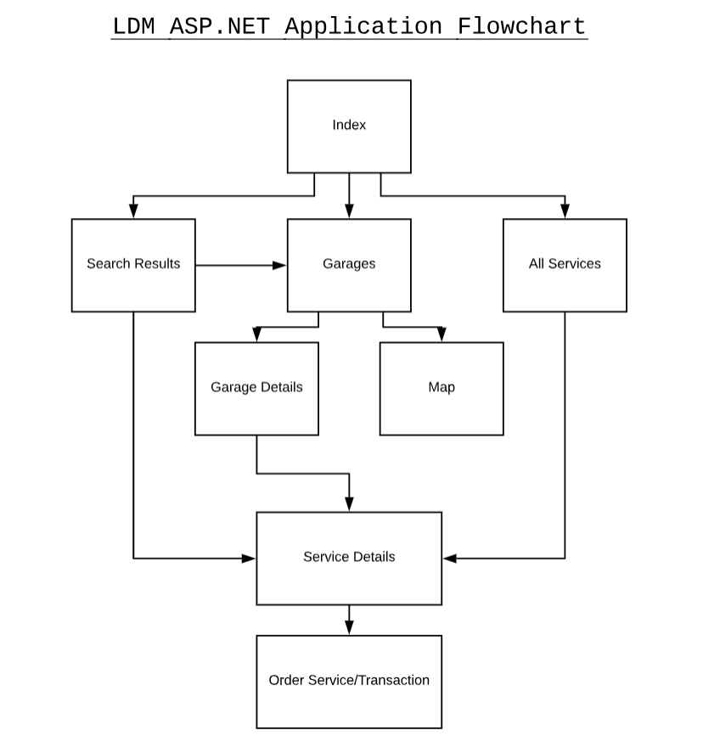

Task distribution among team members:  
Note: Communicate if you start working on a file that may be in use by another member, to avoid conflicts on Git.

Project proposal: each member will add to the proposal

Create project, plan and distribute tasks, create Github repository: Larisa

Create project folder: Larisa

Design POCO classes: Larisa

Create controllers and views: Larisa and Dmitrii

Add CSS classes to the views tags: Matthew

Create layout for nav, footer and master CSS file: Matthew

Forms validation: Larisa and Dmintrii

Final presentation prep: all

Final review: all

Final spelling check: Matthew

Project submission: Larisa